Revision of test paper on Logic Gates

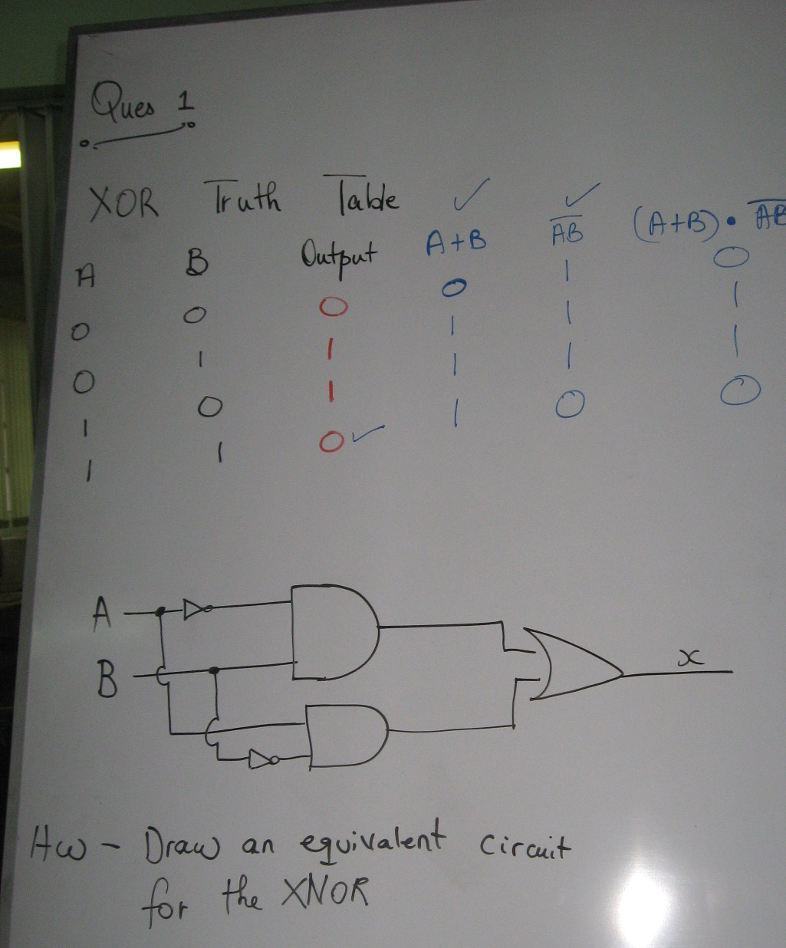

Below is an equivalent circuit for an XOR gate (offered by Krystn Trowers). We used the trace table above to prove.

